Around 300 B.C., a great empire emerged in northern India – the Mauryan Empire. Its most significant ruler was King Asoka. He ruled from 269 B.C. to 232 B.C. Asoka was raised a Hindu. Hinduism was the traditional religion of India. However, he converted to Buddhism after witnessing a particularly bloody battle. When he converted to Buddhism, he became a tolerant ruler who decreed that people of all religions should live peacefully with one another. He improved roads, built hospitals, and sent teachers throughout the empire to encourage education and spread the ideas of Buddhism. After Asoka’s death, the Mauryan Empire began to fall apart.

Questions:

1. List three facts about King Asoka.
2. **Most important ruler of the Mauryan Empire**
3. **Raised a HINDU**
4. **Converts to Buddhism after a bloody battle**
5. **Tolerant Ruler – wanted all people to live in peace and harmony**
6. What did Asoka accomplish during his reign?

* **Improved Roads**
* **Built hospitals**
* **Sent teachers (MISSIONARIES) to spread Buddhism throughout the Empire**

1. What event changed Asoka’s life? Why do you think this event changed Asoka?

**Asoka witnessed/saw a very bloody battle where over 100,000 people died, after seeing all this death and destruction he was horrified. He converts to Buddhism (non-violence) and becomes a tolerant leader who wanted all people to live in peace.**

2- Emperor Asoka was a fierce warrior-king who killed anyone who stood in his way. However, one day, he changed. Asoka was the ruler of the Mauryan Empire from 273 B.C. to 232 B.C. His territory included most of India and parts of what is today Afghanistan and Iran. He was a brutal and bloodthirsty king, and frequently warred against other countries to expand his empire. People called him Chandasoka, or “the cruel Asoka”.

|  |
| --- |
| g1_u31423_Asoka-Empire2 |
|  |

The battle of Kalinga in 250 B.C. changed everything. Asoka was standing on the field after the fighting had ended. Surrounded by the dead bodies, he realized that more than 100,000 people had died because of his war. Horrified, he decided to change. He embraced the Buddhist belief of ahimsa, or non-violence. From that day on, he became known as Dharmasoka, or “the pious Asoka”.

He changed into a kinder ruler, and built many temples and hospitals to help people. Asoka even built hospitals for animals, which was unheard of back then. No longer interested in war, he started sending missions of goodwill to other countries. He also sent Buddhist missionaries to spread the message of peace. Many Buddhists today believe that it was probably because of Asoka that their faith spread so widely. Within his empire, Asoka promoted peaceful debate and discussion as the way to solve problems. He also made sure that all religions were respected.

More than 2,000 years later, Indians still look up to Asoka.

When the modern Republic of India was formed, it chose as its national symbol the lion on top of a pillar he had built.

State Four Fascinating Facts from the Reading:

1. **Built many temple and hospitals**



1. **Brutal bloody king**
2. **Asoka was a tolerant ruler --- he respected all religions**
3. **King Asoka ruled from 273 BC -232 BC**
4. **Asoka sends missionaries (teachers) to encourage education and spread Buddhism**

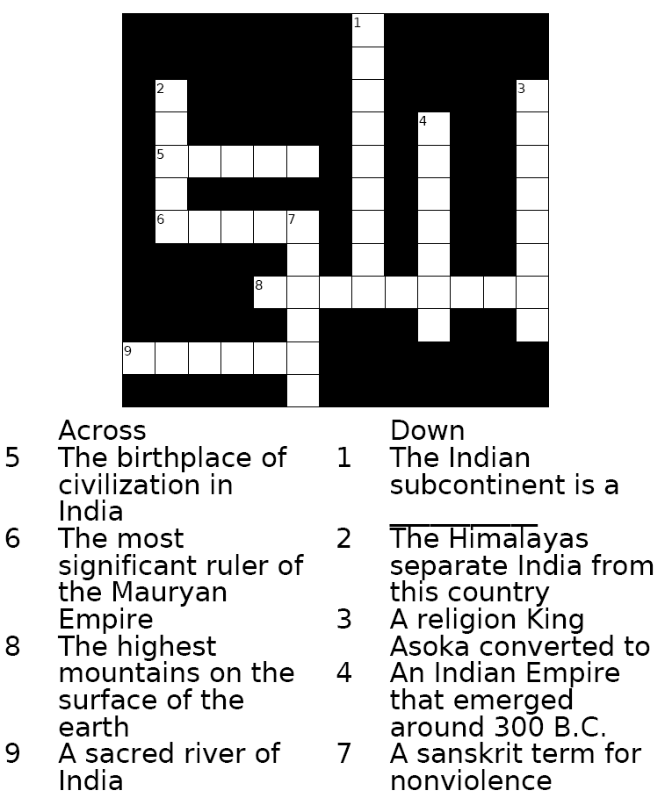



**Word Bank:**

**Ahimsa, Ganges, Asoka, China, Buddhism, Indus, Himalayas, Peninsula, Mauryan**

Working with Documents:

Read the document and answer the question that follows:



Document #1



     "Whoever honors his own [religion] and disparages another man's whether from blind loyalty or with the intention of showing his own [religion] in a favorable light, does his own [religion] the greatest possible harm. Concord is best, with each hearing and respecting the other's teachings. It is the wish of the [king] that members of all religions should be learned and should teach virtue."  
—From the Edicts of Asoka (268 B.C.)



What did the Mauryan ruler, Asoka, say about religious tolerance?



**Believed that people should respect all religions.**\_\_\_\_



1. Throughout history, people have lived on savannas, in deserts, in   
mountains, along river valleys, along coastlines, and on islands.  
This statement demonstrates that people



(1) adapt their surroundings  
(2) develop a common language  
(3) organize similar forms of government  
(4) prefer to live in isolated areas



• If a man has destroyed the eye of a free man, his own eye   
shall be destroyed.  
• If a man has knocked out the teeth of a man of the same rank,   
his own teeth shall be knocked out.

2. These rules are based on the

(1) Analects of Confucius  
(2) Code of Hammurabi  
(3) Ten Commandments  
(4) Koran (Qur’an)

3. What was one effect of Alexander the Great’s conquests?



(1) expansion of Hellenistic culture  
(2) formation of the Christian church  
(3) decreased importance of the Silk Roads  
(4) increased support of the Mayan leaders

